**System Analysis and Design Group Project**

Tom Setterlund

Edhar Zapeka

Vittorio Rosa

Arlene Ata

**ERD Diagram**

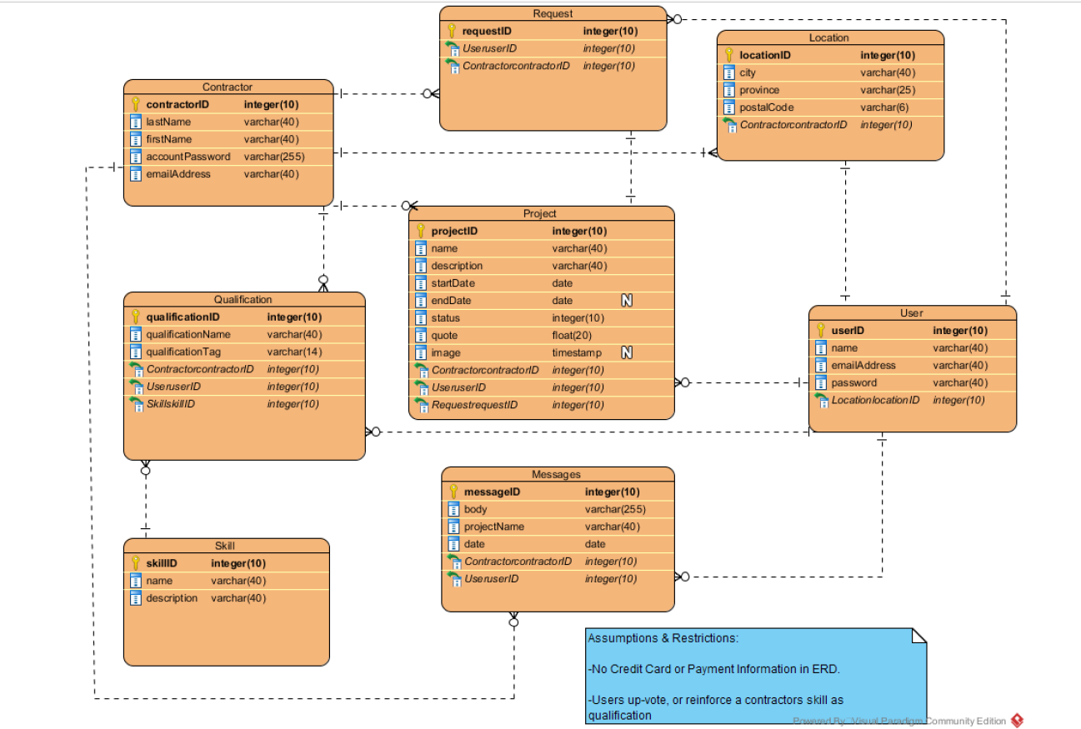

**Use Case Diagram**

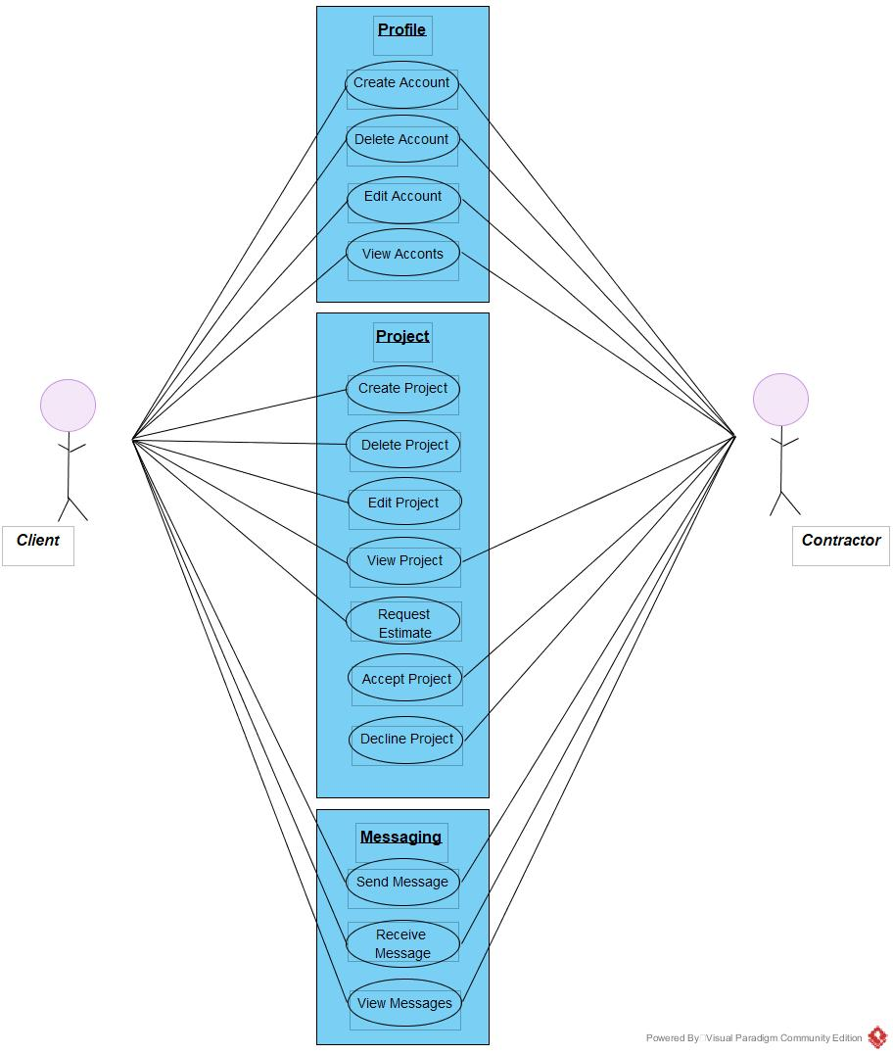

**Functional Features**

**Contractor, users, admin**

Essential:

* Contractor profiles
  + Rating/review system (Qualification)
  + Availability
  + Skills
  + Write up
  + Location
* User Profile
* Ability to up-vote qualifications on contractors page
* Location
* Upload photos of their house (or project)
* Message with contractors
* Personal info and write up
* Contractor Search (through the project page)
  + Skills
  + Reviews
  + Price
  + Area
* Pat’s approval

Important:

* Recommendations if not available
* Response time %
* Project progress-photos etc.
* Disclaimer window before paywall

Extra categories:

* Scheduling and taking jobs
* Professional advice
* Completed projects section for contractor
* More features available for larger projects i.e. Insurance
* Premium access
* Filter by search
  + Skills
  + Reviews
  + Price
  + Area
* Terms of use